**/blend**

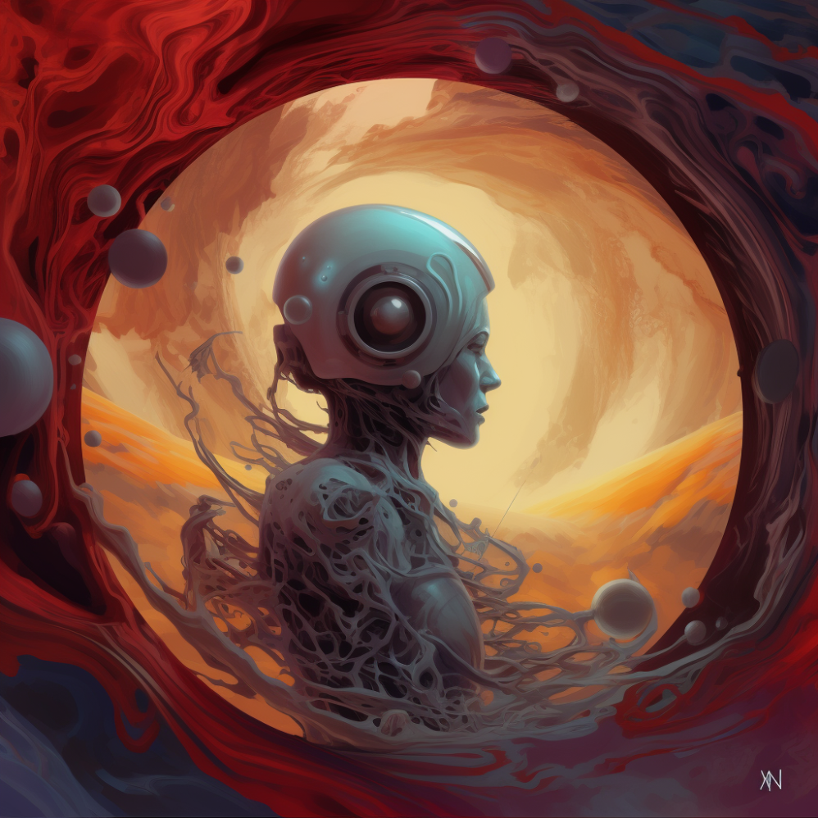

[**https://s.mj.run/aks7bvWvZSo**](https://s.mj.run/aks7bvWvZSo) [**https://s.mj.run/JxfsR51OQBo**](https://s.mj.run/JxfsR51OQBo) [**https://s.mj.run/9ztP1-K06UU**](https://s.mj.run/9ztP1-K06UU) [**https://s.mj.run/vu1jUb0Fu5E**](https://s.mj.run/vu1jUb0Fu5E) [**https://s.mj.run/7oX5A1i6dUg**](https://s.mj.run/7oX5A1i6dUg)

**1️⃣ a robot's head inside a circular shape on an opal background, in the style of peter mohrbacher, digital fantasy landscapes, etam cru, realistic renderings of the human form, mars ravelo, skeuomorphic, fluid**

**2️⃣ computergenerated space art by robert alan, in the style of peter mohrbacher, quiet contemplation, mars ravelo, robotic expressionism, wandering eye, neopunk, high-contrast shading**

**3️⃣ an abstract painting of a man inside a hole in the ground, in the style of detailed science fiction illustrations, futuristic robots, soft color blending, spherical sculptures, crimson and amber, serene faces, futuristic victorian**

**4️⃣ the abstract image of a robot with a red heart, in the style of fluid landscapes, detailed portraiture, spherical sculptures, otherworldly beings, subtle shading, nabis, solarpunk**

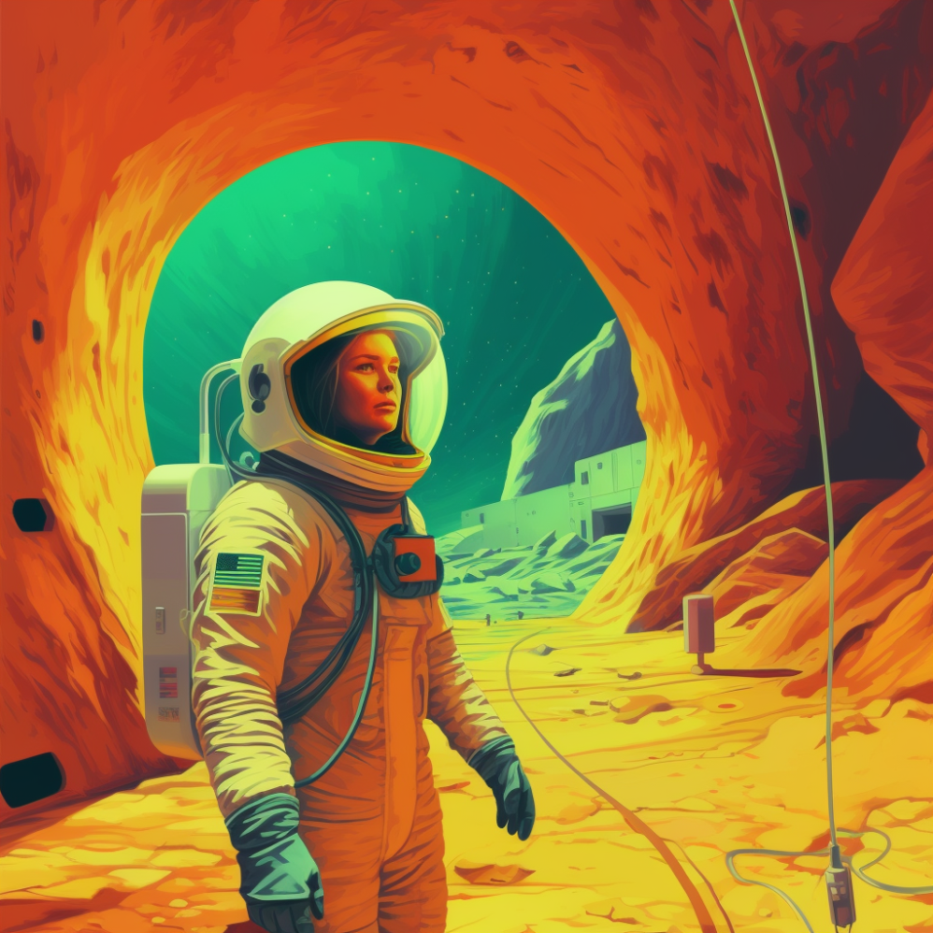

[**https://s.mj.run/lrBcw8pW0JI**](https://s.mj.run/lrBcw8pW0JI) [**https://s.mj.run/bDZRfHiNIoc**](https://s.mj.run/bDZRfHiNIoc)

**1️⃣ a woman in spacesuit is walking through a tunnel, in the style of martin ansin, rhads, earthworks, colorful imagery, realistic detail, justin bua, pictorial space**

**2️⃣ an astronaut standing in a cave, in the style of crisp neo-pop illustrations, realistic hyper-detail, bold color field, green and amber, historical illustrations, cabincore, solarizing master**

**3️⃣ a scene in space with an astronaut and cave, in the style of casey weldon, bold color field, michael ancher, 8k, commission for, steve henderson, womancore**

**4️⃣ pixel art of an astronaut in an underground cave, in the style of realistic figurative paintings, saturated color field, realistic perspective, lyco art, adventure pulp, realistic figurative, human connections**

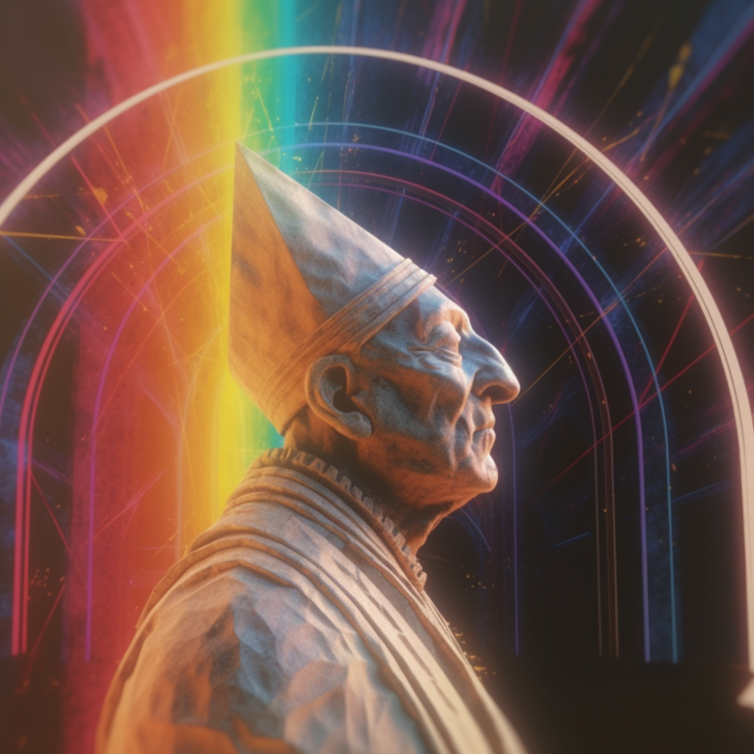

[**https://s.mj.run/94UJ9cP2Wf8**](https://s.mj.run/94UJ9cP2Wf8) [**https://s.mj.run/kCU9z2YHUbQ**](https://s.mj.run/kCU9z2YHUbQ)

**1️⃣ a statue of the pope with rainbow streaks across his face, in the style of unreal engine 5, retro futurism, high detailed, experimental cinematography, adam elsheimer, golden age aesthetics, celestialpunk**

**2️⃣ an antipope statue with an abstract rainbow lighting and bright colors, in the style of realistic hyper-detailed rendering, b-movie aesthetics, focus stacking, detailed perfection, sheet film, recontextualized, glorious**

**3️⃣ the statue of pope is sitting in front of a rainbow rainbow, in the style of rendered in cinema4d, hyper-realistic sci-fi, kinetic light artist, congruent, golden age illustrations, rtx on, 35mm film**

**4️⃣ a statue is sitting in front of a rainbow colored arc, in the style of rendered in cinema4d, pontormo, lens flares, made of wire, anglo gothic, concept art, close up**

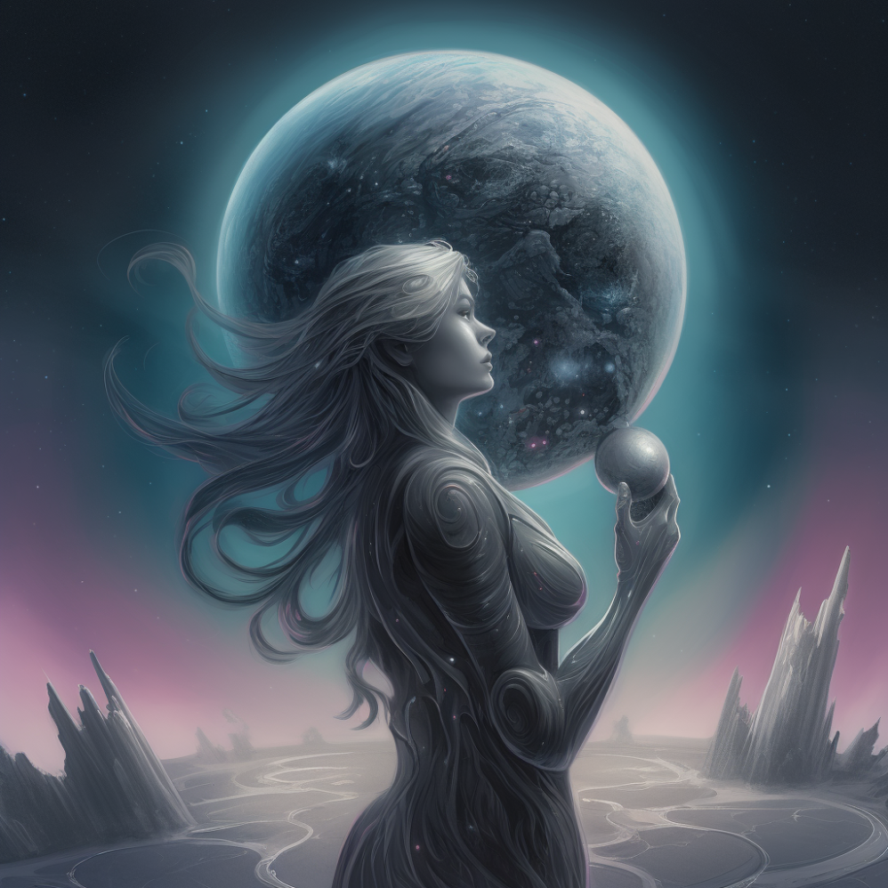

[**https://s.mj.run/pnT9DRMnUpc**](https://s.mj.run/pnT9DRMnUpc) [**https://s.mj.run/M9KWhAwKGj8**](https://s.mj.run/M9KWhAwKGj8) [**https://s.mj.run/4n4AUD10Hqc**](https://s.mj.run/4n4AUD10Hqc)

**1️⃣ a woman holds a large planet in her hands, in the style of artgerm, anton semenov, rodney matthews, 2d game art, nocturne, velvia, quiet contemplation**

**2️⃣ a woman standing on a planet with a large ball in the orbit, in the style of artgerm, necronomicon illustrations, quiet moments captured in paint, ivan albright, dark silver, oleg shuplyak**

**3️⃣ a woman in a spaceship holding a moon, in the style of digital fantasy landscapes, earthcore, dark silver and aquamarine, spherical sculptures, airbrush art, velvia, subtle shading**

**4️⃣ the woman is looking into something green with a star in the orbit, in the style of realistic fantasy artwork, dark silver and sky-blue, bulbous, highly detailed figures, earthcore, fantasy landscapes, trace monotone**

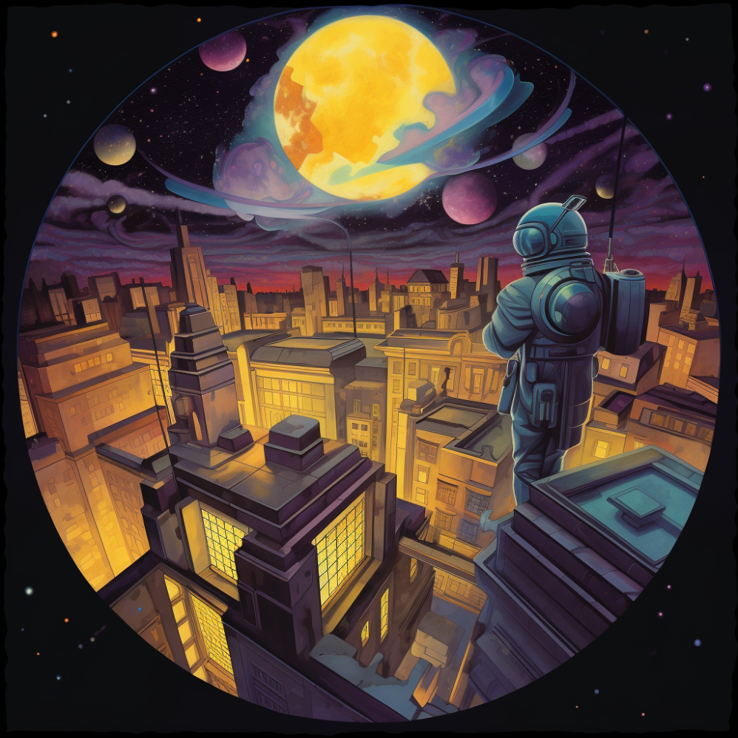

[**https://s.mj.run/JsGVZak3KZg**](https://s.mj.run/JsGVZak3KZg) [**https://s.mj.run/Mp00akvjzhY**](https://s.mj.run/Mp00akvjzhY) [**https://s.mj.run/9_gQi8ukcgg**](https://s.mj.run/9_gQi8ukcgg)

**1️⃣ a poster with a man in an astronaut outfit looking out over the city, in the style of psychedelic illustration, fisheye lens, masterful shading, nocturne, spherical sculptures, trompe l’oeil, detailed world-building**

**2️⃣ a spaceman is looking at the moon, in the style of cubist cityscapes, jason edmiston, tondo, jeff danziger, emily balivet, new york cityscape, imaginary creatures and robots**

**3️⃣ a portrait with a planetarium looking toward the sky, in the style of surreal city scenes, nightmarish illustrations, high-angle, chromatic harmony, ps1 graphics, sgrafitto**

**4️⃣ the new planet cover by person, in the style of cubist cityscapes, jeremiah ketner, charles wysocki, nocturne, high-angle, zeiss otus 85mm f/1.4 apo planar t*, illustrative**